**Practical No. 05**

**TITLE:** TEMPERATURE CONVERTER USING ANDROID STUDIO

**AIM:** IMPLEMENT TEMPERATURE CONVERTER USING ANDROID STUDIO

**APPARATUS:** ANDROID STUDIO

**THEORY:**

In this Android program we will convert temperature from Celsius to Fahrenheit and from Fahrenheit to Celsius. This will be done with the help of a Button. We will be using two formulas one to convert temperature from Celsius to Fahrenheit which is *“(temp *1.8) + 32*” and from Fahrenheit to Celsius which is *“(temp - 32) / 1.8*”.

* **activity_main.xml**

<?xml version="1.0" encoding="utf-8"?>

<androidx.appcompat.widget.LinearLayoutCompat xmlns:android="http://schemas.android.com/apk/res/android"

xmlns:app="http://schemas.android.com/apk/res-auto"

xmlns:tools="http://schemas.android.com/tools"

android:layout_width="match_parent"

android:layout_height="match_parent"

android:orientation="vertical"

tools:context=".MainActivity"

android:background="@drawable/backnew">

<androidx.appcompat.widget.Toolbar

android:layout_width="match_parent"

android:background="@color/lightviolet"

android:layout_height="?attr/actionBarSize">

<RelativeLayout

android:layout_width="match_parent"

android:layout_height="wrap_content"

android:gravity="center_vertical">

<TextView

android:layout_width="wrap_content"

android:layout_height="match_parent"

android:layout_alignParentStart="true"

android:layout_marginStart="8dp"

android:gravity="center"

android:text="@string/app_name"

android:textColor="@color/lightblue"

android:textSize="25dp"

android:textStyle="bold" />

<ImageView

android:layout_width="wrap_content"

android:layout_height="match_parent"

android:layout_alignParentEnd="true"

android:layout_marginStart="240dp"

android:layout_marginEnd="-31dp"

android:src="@drawable/add" />

</RelativeLayout>

</androidx.appcompat.widget.Toolbar>

<TextView

android:layout_width="wrap_content"

android:layout_height="match_parent"

android:layout_alignParentStart="true"

android:layout_marginStart="8dp"

android:gravity="center"

android:text="@string/app_name"

android:textColor="@color/lightblue"

android:textSize="25dp"

android:textStyle="bold" />

<ImageView

android:layout_width="wrap_content"

android:layout_height="match_parent"

android:layout_alignParentEnd="true"

android:layout_marginStart="240dp"

android:layout_marginEnd="-31dp"

android:src="@drawable/add" />

</RelativeLayout>

</androidx.appcompat.widget.Toolbar>

<TextView

android:id="@+id/TempConvWel"

android:layout_gravity="center"

android:gravity="center"

android:layout_marginTop="11dp"

android:layout_marginBottom="8dp"

android:layout_width="match_parent"

android:layout_height="wrap_content"

android:shadowColor="@color/white"

android:padding="2dp"

android:text="Welcome To Temperature Converter"

android:textColor="@color/lightorange"

android:textStyle="bold"

android:textSize="21dp"

/>

<ImageView

android:layout_margin="8dp"

android:src="@drawable/temp"

android:layout_width="400dp"

android:layout_height="250dp"

android:padding="2dp"

android:layout_marginBottom="7dp"

android:layout_gravity="center"

/>

**Conclusion:** Thus we implemented the installation o

android:textStyle="bold"

android:textSize="21dp"

/>

<ImageView

android:layout_margin="8dp"

android:src="@drawable/temp"

android:layout_width="400dp"

android:layout_height="250dp"

android:padding="2dp"

android:layout_marginBottom="7dp"

android:layout_gravity="center"

/>

<EditText

android:id="@+id/editText"

android:textStyle="italic"

android:layout_width="wrap_content"

android:layout_height="wrap_content"

android:layout_gravity="center"

android:hint="Enter Temperature"

android:textColor="@color/lightgreen"

android:textColorHint="@color/lightgreen"

android:inputType="numberSigned"

android:ems="10"

android:textAlignment="center"

android:textSize="23dp"

android:layout_marginTop="7dp"

/>

<Button

android:id="@+id/cToF"

android:layout_width="match_parent"

android:layout_height="wrap_content"

android:textAlignment="center"

android:shadowColor="@color/black"

android:text="Celsius To Fahrenheit"

android:textSize="25dp"

android:layout_gravity="center"

android:layout_marginTop="25dp"

android:backgroundTint="@color/lightyellow"

android:textStyle="bold"

android:textAllCaps="false"

android:elevation="18sp"

android:textColor="@color/darkblue"/>

android:textAlignment="center"

android:shadowColor="@color/black"

android:text="Celsius To Fahrenheit"

android:textSize="25dp"

android:layout_gravity="center"

android:layout_marginTop="25dp"

android:backgroundTint="@color/lightyellow"

android:textStyle="bold"

android:textAllCaps="false"

android:elevation="18sp"

android:textColor="@color/darkblue"/>

<Button

android:id="@+id/fToC"

android:layout_width="match_parent"

android:layout_height="wrap_content"

android:text="Fahrenheit To Celsius"

android:textSize="25dp"

android:textAlignment="center"

android:layout_gravity="center"

android:layout_marginTop="25dp"

android:backgroundTint="@color/lightpink"

android:textStyle="bold"

android:shadowColor="@color/black"

android:elevation="18sp"

android:textAllCaps="false"

android:textColor="@color/darkblue"/>

<TextView

android:id="@+id/result"

android:layout_width="wrap_content"

android:layout_height="wrap_content"

android:text="0 Degrees"

android:textStyle="bold"

android:textAlignment="center"

android:textAllCaps="false"

android:textColor="#f3c4fb"

android:textSize="25dp"

android:layout_gravity="center"

android:layout_marginTop="61dp"/>

</androidx.appcompat.widget.LinearLayoutCompat>

android:textStyle="bold"

android:textAlignment="center"

android:textAllCaps="false"

android:textColor="#f3c4fb"

android:textSize="25dp"

android:layout_gravity="center"

android:layout_marginTop="61dp"/>

</androidx.appcompat.widget.LinearLayoutCompat>

* **MainActivity.java**

package com.example.temperatureconverter;

import androidx.appcompat.app.AppCompatActivity;

import android.annotation.SuppressLint;

import android.os.Bundle;

import android.text.TextUtils;

import android.view.View;

import android.widget.Button;

import android.widget.EditText;

import android.widget.TextView;

import android.widget.Toast;

public class MainActivity extends AppCompatActivity {

private Button cToF, fToC;

private TextView result;

private EditText enterTemp;

double result0;

@SuppressLint("MissingInflatedId")

@Override

protected void onCreate(Bundle savedInstanceState) {

super.onCreate(savedInstanceState);

setContentView(R.layout.activity_main);

cToF = findViewById(R.id.cToF);

fToC = findViewById(R.id.fToC);

result = findViewById(R.id.result);

enterTemp = findViewById(R.id.editText);

cToF.setOnClickListener(new View.OnClickListener() {

@Override

fToC = findViewById(R.id.fToC);

result = findViewById(R.id.result);

enterTemp = findViewById(R.id.editText);

cToF.setOnClickListener(new View.OnClickListener() {

@Override

public void onClick(View view) {

Toast.makeText(MainActivity.this, "Thanks For Using", Toast.LENGTH_SHORT).show();

double temp = Double.parseDouble(enterTemp.getText().toString());

result0 = (temp *1.8) + 32;

result.setText(String.valueOf(result0));

}

});

fToC.setOnClickListener(new View.OnClickListener() {

@Override

public void onClick(View view) {

Toast.makeText(MainActivity.this, "Thanks For Using", Toast.LENGTH_SHORT).show();

double temp = Double.parseDouble(enterTemp.getText().toString());

result0 = (temp - 32) / 1.8;

result.setText(String.valueOf(result0));

}

});

}

}

* **Project Files –**

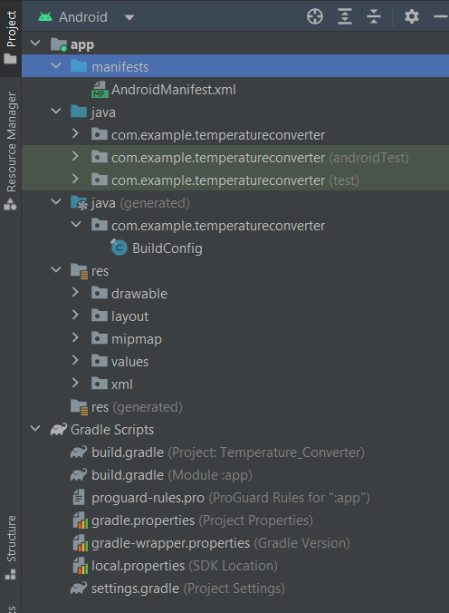

* **Output on Emulator –**

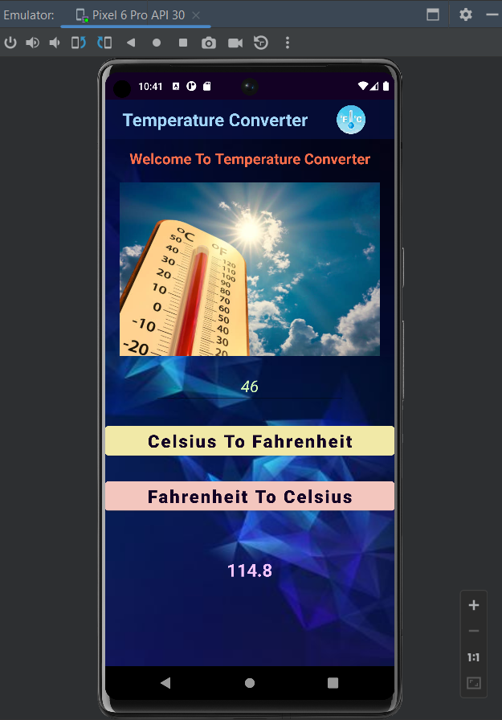

**Conclusion:** Thus we studied the implementation of Hello world on Android Studio.